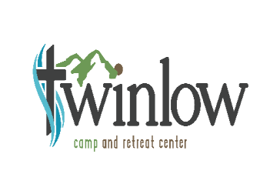
Spokane Valley United Methodist Church

Day Camp/Vacation Bible School

Camper Registration Form
July 16th-20th; 9a.m.-3p.m. Monday through Thursday, 9a.m.-12p.m. Friday
Please print clearly in ink. Please use a different form for each camper. This form is necessary for participation in Day Camp.
Camper Name:
Age: Grade (going into this fall):
Home Church (If appropriate):
Parent/Guardian Name:
Address:
Cell Number:
Home Number:
Work Number:
Email:
Emergency Contact Person (different from above):
Work Number:
Cell Number:
Relation to Camper:
Name of home church, if any:
People allowed to pick-up your child:
People NOT allowed to pick-up your child:
Insurance Information
Insurance Carrier or Plan Name:
Group #:
Carrier Address/City/State/Zip:
Name of Insured:
Relationship:
Insurance ID or Policy #:
Current Health Conditions - Please describe any current health conditions requiring medications, treatment, or special restrictions or considerations while at church.

Past Medical Conditions/Health History - Please describe past medical treatment, (i.e., surgeries, heart conditions, fainting, seizures, etc.) or other medical concerns.

Allergies - List all known allergies including those involving medication, food, insect, asthma, hay fever and other allergies. Please describe reaction and management. If your child has no allergies please write “none”.
ALLERGY REACTION AND TREATMENT
________________________________ ______________________________________
________________________________ ______________________________________
Parent or Guardian Authorization
I give Twinlow Camp permission to use photos/video of my child taken at Day Camp in future promotion of Twinlow Camp ministries.
I, the undersigned parent/guardian, give permission for the above named child to participate in the activity indicated above. I recognize and acknowledge that this activity can involve certain hazards, including, but not limited to, illness, injury and accidents, and I therefore release Spokane Valley United Methodist Church and The United Methodist Church from liability.
I give permission for:
- Standard medical treatment
- Emergency medical treatment in the case that I cannot be contacted
- Release of information for insurance purposes
- Photos to be used in future publicity
The following health history is accurate and complete as far as I know.
Parent or Guardian Signature:
Date:
The above information must be filled in by the parent/guardian. The intent of this information is to provide the Christian Education Program at Spokane Valley United Methodist Church the background to provide health care personnel the background to provide appropriate care. KEEP A COPY OF THE COMPLETED FORM FOR YOUR RECORDS. Any changes to this form should be provided to VBS Staff upon participant’s arrival at VBS.

